High-Level Design Specifications
Cylinders & Orders Management System (COMS) Project
This document establishes the high-level design of the system. It defines the proposed software architecture, the transition from analysis to design, and the database design for the development of the COMS project.
3/7/2011

This page has been intentionally left blank

Filing Reference : | GG/COMS/TS.2/v1
Document Title: | High-level Design Specifications
Version : | 1.0
Prepared by : | Tran Ba Tien
Date Created : | Friday, July 1st, 2011
Approved by : | ___________________
 | Maung Tin Kyaw Oo |  | Date
 | Technical Lead
Authorized by : | ___________________
 | Alvin Chang |  | Date
 | Quality Manager
© 2011 Hoang Kim Joint Stock Company.
The information contained in this document is the property of Hoang Kim Joint Stock Company. The contents must not be reproduced, wholly or in part, for purposes other than for which it has been supplied, without the prior permission of Hoang Kim Joint Stock Company, or, if it has been furnished under contract to another party, as expressly authorised under that contract. Hoang Kim Joint Stock Company shall not be liable for any errors or omissions.

Document Reference: GG/COMS/TS.2/v1
Version | Date | Author | Remarks | Authorised by
1.0 | 01/07/2011 | Tran Ba Tien | Created Document
Cylinders & Orders Management System (COMS)
Project
High-level Design Specifications
Distribution:
Name | Department | Organisation
Truong Thieu Duong | Main Office | Hoang Kim Joint Stock Company
Tran Ba Tien | SE18-Team2S | MTech (ISS)
Maung Tin Kyaw Oo | SE18-Team2S | MTech (ISS)
Chang Parkk Khiong Alvin | SE18-Team2S | MTech (ISS)
Koh Ming Jin | SE18-Team2S | MTech (ISS)
Junaith | SE18-Team2S | MTech (ISS)
Phyo Phyo Lwin | SE18-Team2S | MTech (ISS)

Table of Contents

1. INTRODUCTION. 1
1.1 Purpose 1
1.2 Audience 1
1.3 Organisation 1
1.4 References 1
2. OVERVIEW OF REQUIREMENTS 2
1.5 System Interface 2
1.6 System Functions 2
3. SYSTEM OVERVIEW. 2
3.1. Sales Order, Cylinder and Employee Info Management. 2
3.2. Cylinder Manufacturing Process Management 2
3.3. Employee Performance Management 3
2. TRANSITION FROM ANALYSIS TO DESIGN 4
a. Introduction 4
b. Web Client GUI 4
c. Thick Client GUI 4
d. Class Diagram 4
Figure 1: Sample Analysis Class Diagram 4
Figure 2: Translated Design Class Diagram 5
3. DATABASE DESIGN 5
Figure 3: COMS Database Schema 6
COMS_CUSTOMER 6
COMS_CYLINDER 7
COMS_CYLINDER_LOG 7
COMS_DEPARTMENT 7
COMS_EMP_ROLE_RLTS 7
COMS_EMPLOYEE 7
COMS_ERROR 8
COMS_FORMULA 8
COMS_ORDER 8
COMS_ORDER_DETAIL 8
COMS_ROLE 8
COMS_ROLE_RIGHT_RLTS 9
COMS_STEP 9
COMS_WORKFLOW 9
4. SYSTEM ARCHITECTURE 10
4.1. Web Client 10
a. Cylinder Status Update Page 10
b. Login Page 10
c. Sales Order Menu 10
d. Cylinder Menu 11
e. Employee Menu 11
f. Queue Menu 11
g. Role Menu 11
h. User Account Menu 12
i. Formula Menu 12
j. Error Menu 12
k. Log Out Menu 13
4.2. Thick Client 13
a. Login Page 13
b. Workflow Menu 13
c. Step Menu 13
d. Performance Formula Menu 14

1. INTRODUCTION.
Hoang Kim Joint Stock Company is one of the leading providers of printing cylinders in Vietnam. They are currently using the latest technologies from Germany and Japan, and their client bases include various Vietnamese corporations as well as across Southeast Asia.
The company would like to have an integrated IT system that can:
- Manage the main manufacturing process, i.e. sales orders and cylinders.
- Benchmark employees’ performance to calculate bonuses.
- Give management reporting tools for daily operations.
- Be easy to maintain and to add new features in the future.

Purpose
The purpose of this document is to provide system specifications for the COMS project. It defines the proposed software architecture, the transition from analysis to design, and the database design for the development of the COMS project.

Audience
The intended reader of this High-level Design Specs is the project team to:
- provide an overview of the design of the system to be implemented;
- transform the various analysis use case scenarios to the chosen platform and technology;
- reference the database design to perform the correct data operations

Organisation
The overview of the requirements of the project is summarised in Section 2 and section 3. The transition from analysis to design is described in Section 4. Section 5 describes the database design and Section 6 gives details of the system’s menu items.

References
To fully understand the background to this project, the reader should also be familiar with the COMS User Requirement Specs (reference GG/COMS/TS.1).

2. OVERVIEW OF REQUIREMENTS

System Interface
Currently, the system does not need to interface with any other system.

System Functions
The following system functions are to be implemented in this system.
- Managing of print sales order data, including list of cylinders belonging to the sales order.
- Managing of cylinder data.
- Managing of employee data, including management of roles.
- Managing manufacturing work flow, including progress log for each cylinder & function to draw flow charts.
- Generating cylinder statistics reports (by status, current step, etc.) & employee statistics reports (by marks, time range, errors, etc.).
- Managing of employee performances and bonus calculation.

3. SYSTEM OVERVIEW.
COMS performs the primary functions of manufacturing, as specified in the following subsections

Sales Order, Cylinder and Employee Info Management.
- Allow sales staff to create sales order.
- Allow authorized sales staff to add / update / remove / delete cylinders from a sales order.
- Allow sales order and cylinder data to be viewed by authorized users.
- Allow mechanical department manager to print cylinder data.
- Allow all department managers to manage subordinates’ roles. Some roles require approval from directors.
- There will be an indicator at cylinder type setup to set as Replace / Normal / Backup to allow how many cylinders are for Replace / Normal and Backup purpose.
- There will be an indicator at cylinder making technology setup to set as Electro-mechanical engraving / Laser engraving.

Cylinder Manufacturing Process Management
  - Allow workers to scan to update cylinder status immediately after completing a step, link the worker id to that step for that cylinder, and note the amount of time required, for performance grading. The update in status will be logged and can be accessible at anytime.
  - Each cylinder will have a priority level. Under a step, higher-priority cylinders must be processed first.
  - Allow operation managers to update the schedule for a step.
  - Allow workers to send a faulty cylinder to the previous step, and log the error from a list of error code or by text. The error will be linked to the step where it occurred.
  - These error descriptions can be viewed and changed.
  - Allow operation managers to send a faulty cylinder to a step not according to the work flow.
  - Allow operation managers to stop processing a cylinder or stop processing a sales order. Also allow them to resume processing that cylinder or sales order. This role can only be granted by IT staff and requires approval from a director.
  - Allow mechanical dept. manager to print cylinder progress form (for scanning barcode).
  - Allow managers to view all cylinders currently under one step.
  - Allow managers to export schedules into excel.
  - Allow all staff to view cylinder’s progress log and sales order’s progress log.
  - Allow department managers to change the work flow(list of steps) in their own departments. Using GUI to make changes to steps in workflow steps.

Employee Performance Management
- Calculate and store the mark a worker achieves after he performed a step, based on a specified formula.
- Allow accounting staffs to print out workers’ list of marks achieved during a period. They can also print out the list of step for reference.
- Allow accounting staffs to modify performance formulas, based on 4 specified constants and other parameters such as cylinder size, number count, or colour count in the sales order.
- Allow one step to have more than one formulas. Based on cylinder characteristics such as size, hollowness, the system will pick the suitable formula in real time.
- Allow managers to view a worker performance (e.g. number of cylinders he worked on) during a period.
- Allow managers to view list of errors occurred under a step during a period, filterable by each worker.

4. TRANSITION FROM ANALYSIS TO DESIGN

Introduction
We decided to implement the system in .NET platform, running in Internet Information Services (IIS) server application and uses Microsoft SQL Server database. The choice of technology and platform was made due to the IT staff on customer site is more familiar with .NET. Therefore we will be able to roll out and hand over the system more easily and reduce learning curve. Also there is a lean towards .NET development in Vietnam IT industry, so it would help in case the customer would like to enhance the system and decides to hire more staff. Furthermore the existing Windows Server 2003 environment would require less setup to host a .NET application.

Web Client GUI
Since most functions do not require a complicated UI, and the number of client workstation is large, we decided to go for a web application. It would reduce maintenance cost in terms of client-side installation and future updates. There would also be a control of direct access to the database, increasing security and system stability. On the other hand, we will need to cater to connection issues during transactions, and web browser compatibility.

Thick Client GUI
However, there are a few functions that require a complex GUI, namely the management of work flows and production steps. For this we will implement a thick client written in .NET. The thick client will use web services to talk to the server side. In doing this, in the future the web services can be reused, or other parts of the system can be exposed by web services successfully as well if there is a need.

Class Diagram
The sample analysis diagram and translated design diagram are presented as below. The analysis boundary class has become .ASPX classes for web clients / .CS for thick client which calls the controller objects through the .WCS web service class. The controller and entity classes have become .CS classes.

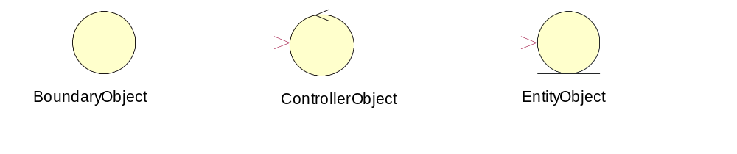
Figure 1: Sample Analysis Class Diagram

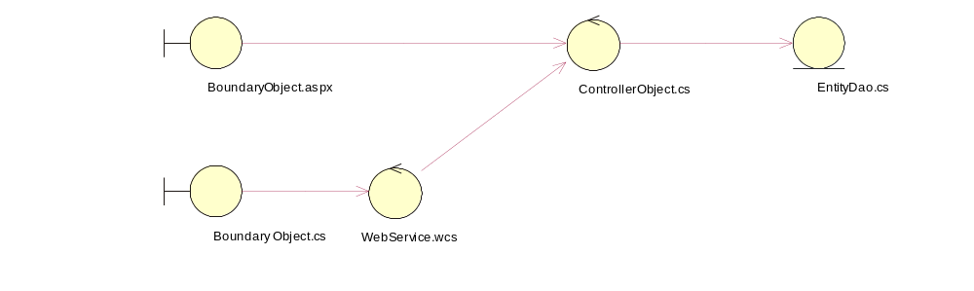
Figure 2: Translated Design Class Diagram

5. DATABASE DESIGN
The database design for the system is described as follow.
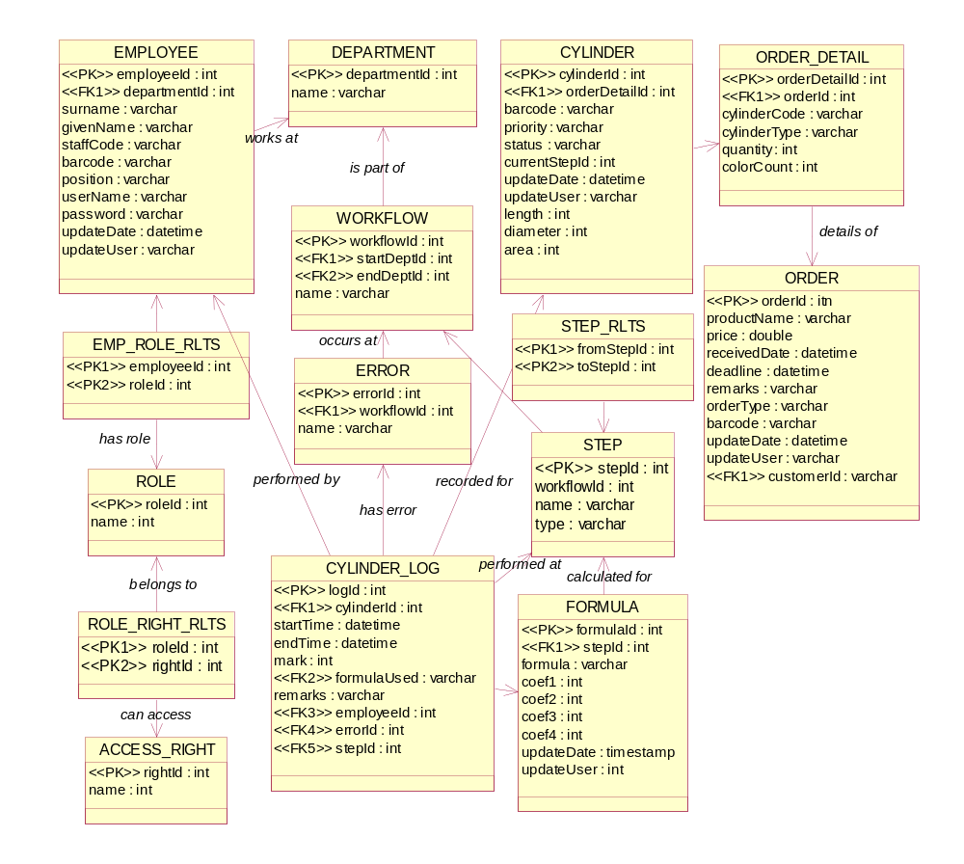
Figure 3: COMS Database Schema

ACCESS_RIGHT
Name | Type | Description
rightId | int | Primary Key
name | int

CYLINDER
Name | Type | Description
cylinderId | int | Primary Key
orderDetailId | int | Foreign Key
barcode | varchar
priority | varchar
status | varchar
currentStepId | int | Foreign Key
updateDate | datetime
updateUser | varchar
length | int
diameter | int
area | int

CYLINDER_LOG
Name | Type | Description
logId | int | Primary Key
cylinderId | int | Foreign Key
startTime | datetime
endTime | datetime
mark | int
formulaUsed | varchar | Foreign Key
remarks | varchar
employeeId | int | Foreign Key
errorId | int | Foreign Key
stepId | int | Foreign Key

DEPARTMENT
Name | Type | Description
departmentId | int | Primary Key
name | varchar

EMP_ROLE_RLTS
Name | Type | Description
employeeId | int | Primary Key
roleId | int | Primary Key

EMPLOYEE
Name | Type | Description
employeeId | int | Primary Key
departmentId | int | Foreign Key
surname | varchar
givenName | varchar
staffCode | varchar
barcode | varchar
position | varchar
userName | varchar
password | varchar
updateDate | datetime
updateUser | varchar

ERROR
Name | Type | Description
errorId | int | Primary Key
workflowId | int | Foreign Key
name | varchar

FORMULA
Name | Type | Description
formulaId | int | Primary Key
stepId | int | Foreign Key
formula | varchar
coef1 | int
coef2 | int
coef3 | int
coef4 | int
updateDate | timestamp
updateUser | int

ORDER
Name | Type | Description
orderId | itn | Primary Key
productName | varchar
price | double
receivedDate | datetime
deadline | datetime
remarks | varchar
orderType | varchar
barcode | varchar
updateDate | datetime
updateUser | varchar
customerId | varchar | Foreign Key

ORDER_DETAIL
Name | Type | Description
orderDetailId | int | Primary Key
orderId | int | Foreign Key
cylinderCode | varchar
cylinderType | varchar
quantity | int
colorCount | int

ROLE
Name | Type | Description
roleId | int | Primary Key
name | int

ROLE_RIGHT_RLTS
Name | Type | Description
roleId | int | Primary Key
rightId | int | Primary Key

STEP
Name | Type | Description
stepId | int | Primary Key
workflowId | int | Foreign Key
name | varchar
type | varchar

STEP_RLTS
Name | Type | Description
fromStepId | int | Primary Key
toStepId | int | Primary Key

WORKFLOW
Name | Type | Description
workflowId | int | Primary Key
startDeptId | int | Foreign Key
endDeptId | int | Foreign Key
name | varchar

6. SYSTEM ARCHITECTURE

Software Architecture
The software architecture is described as below.
- Web clients uses web browser to connect to .NET web server.
- .NET thick client connects to web service component of .NET server.
- .NET server has 3 layers:
  - Presentation layer: .aspx pages to display web content and .wcs classes to expose web services.
  - Controller layer: .cs classes to hold the business logic
  - Data access layer: .cs classes using Entity Framework to access the database.
- .NET server has direct connection to MS SQL Database server.

Physical Architecture
The physical architecture is described as below.
- All components are connected through LAN network. Internet connection is not required.
- Only .NET server has access to MS SQL Database server.

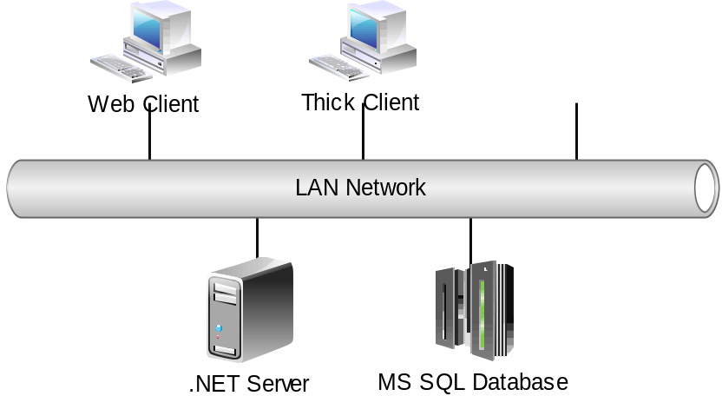
Figure: Physical Architecture Layout

Web Client
The home page of the web client contains these 2 menu items:
- Cylinder Status Update Page
- Login Page

Cylinder Status Update Page
Here the user can update the cylinder status without the need to login with the following input:
Input | Type | Description
Cylinder Code | Text Input | Scan barcode or enter by keyboard
Step | Drop-down List | Select from list
Employee Code | Text Input | Scan barcode or enter by keyboard

Login Page
Here the user can log in to the system with the following input:
Input | Type | Description
Username | Text Input | Enter by keyboard
Password | Password Input | Enter by keyboard

After logging in, user will be able to access the main page with the following menu items (subject to user’s assigned roles and access rights)
- Sales Order Menu
- Cylinder Menu
- Employee Menu
- Queue Menu
- Role Menu
- User Account Menu
- Formula Menu
- Error Menu
- Log Out Menu

Sales Order Menu
Here the user can perform the following functions:
Page | Action | Description
Create Sales Order | Create | Create new sales order and add cylinders to it
Manage Sales Order | Search, Update, Delete | Search, Update, Delete
View Order Progress | View | View the status of all cylinder belonging to sales order
Start/Stop Production Process | Start, Stop | Start the production of the cylinders under the sales order

Cylinder Menu
Here the user can perform the following functions:
Page | Action | Description
Print Cylinder Info | Search, Print | View cylinder info and print out
Update Cylinder Priority | Search, Update
View Cylinder Progress Log | View | View all the work performed on the cylinder
Send Cylinder To Step | Update | Move cylinder to another step

Employee Menu
Here the user can perform the following functions:
Page | Action | Description
Create Employee | Create | Create new employee
Manage Employee | Search, Update, Delete, Manage –Employee-Role | Search, Update, Delete
Print Worker’s Mark Report | View | View the status of all cylinder belonging to sales order

Queue Menu
Here the user can perform the following functions:
Page | Action | Description
View Queue | View, Export to Excel | View the list of cylinder currently under a workflow

Role Menu
Here the user can perform the following functions:
Page | Action | Description
Create Role | Create | Create new role and assign access rights to role
Manage Role | Search, Update, Delete | Search, Update, Delete
Approve Role Change | Approve | Approve role-change requested by another user
Create Access Rights | Create | Create new access right
Manage Access Rights | Search, Update, Delete | Search, Update, Delete

User Account Menu
Here the user can perform the following functions:
Page | Action | Description
Create User Account | Create | Create new user account
Manage User Account | Search, Update, Delete

Formula Menu
Here the user can perform the following functions:
Page | Action | Description
Create Employee | Create | Create new employee
Manage Employee | Search, Update, Delete, Manage –Employee-Role
Print Worker’s Mark Report | View | View the status of all cylinder belonging to sales order

Error Menu
Here the user can perform the following functions:
Page | Action | Description
Create Error | Create | Create new error and assign to a workflow
Manage Error | Search, Update, Delete | Search, Update, Delete

Log Out Menu
Here the user can perform the following functions:
Page | Action | Description
Log Out | Log Out

Thick Client
The home page of the thick client contains these menu items:
- Login Page

Login Page
Here the user can log in to the system with the following input:
Input | Type | Description
Username | Text Input | Enter by keyboard
Password | Password Input | Enter by keyboard

After logging in, user will be able to access the main page with the following menu items (subject to user’s assigned roles and access rights)
- Workflow Menu
- Step Menu
- Performance Formula Menu

Workflow Menu
Here the user can perform the following functions:
Page | Action | Description
Create Workflow | Create | Create new workflow and add steps to it
Manage Workflow | Search, Update, Delete | Search, Update, Delete

Step Menu
Here the user can perform the following functions:
Page | Action | Description
Create Step | Create | Create new step and link to other steps
Manage Step | Search, Update, Delete | Search, Update, Delete
Print Step List | View

Performance Formula Menu
Here the user can perform the following functions:
Page | Action | Description
Create formula | Create | Create new formula and assign to a step
Manage formula | Search, Update, Delete | Search, Update, Delete

